**Session Login Project (MVC)**

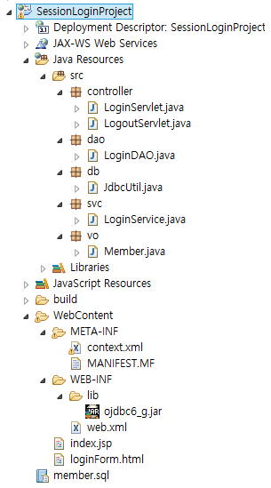

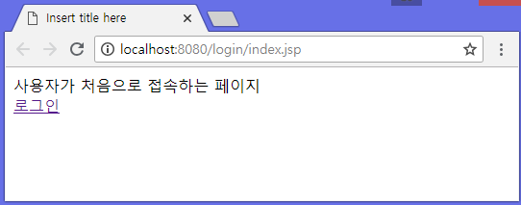

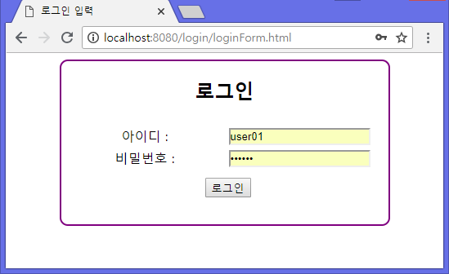

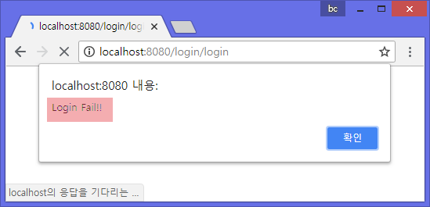

java/java

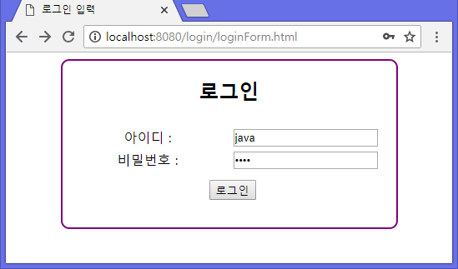

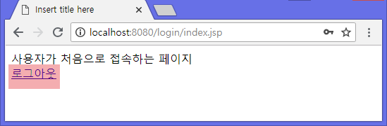

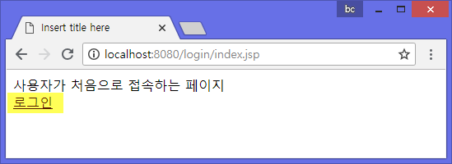

|  |
| --- |
| **CREATE** **TABLE** users(  id VARCHAR2(12) **PRIMARY** **KEY**,  passwd VARCHAR2(12),  addr VARCHAR2(50),  age NUMBER,  email VARCHAR2(30),  gender **CHAR**(1),  name VARCHAR2(12),  nation VARCHAR2(16)  );  **INSERT** **INTO** users **VALUES**('java','java','서울시',40,'aaa@aaa.com','M','홍길동','대한민국');  **COMMIT**; |

[index.jsp]

|  |
| --- |
| <%@ page language=*"java"* contentType=*"text/html; charset=UTF-8"*  pageEncoding=*"UTF-8"*%>  <!DOCTYPE html PUBLIC "-//W3C//DTD HTML 4.01 Transitional//EN" "http://www.w3.org/TR/html4/loose.dtd">  <html>  <head>  <meta http-equiv=*"Content-Type"* content=*"text/html; charset=UTF-8"*>  <title>Insert title here</title>  </head>  <body>  </body>  </html> |

[loginForm.html ]

|  |
| --- |
| <!DOCTYPE html>  <html>  <head>  <meta charset=*"UTF-8"*>  <title>로그인 입력</title>  <style>  *#loginFormArea*{  margin : *auto*;  width : *400px*;  height : *200px*;  border : *2px double purple*;  border-radius : *10px*;  text-align: *center*;  }  **fieldset**{  text-align: *center*;  border : *none*;  }  *#selectButton*{  margin-top : *10px*;  }  **table**{  width : *380px*;  margin : *auto*;  }  *.td_left*{  width : *180px*  }  *.td_right*{  width : *200px*  }  </style>  </head>  <body>  </body>  </html> |

[context.xml ]

|  |
| --- |
|  |

[Member.java ]

|  |
| --- |
| **package** vo;  **public** **class** Member {  **private** String name;  **private** String addr;  **private** **int** age;  **private** String nation;  **private** String id;  **private** String passwd;  **private** String gender;  **private** String email;    **public** String getName() {  **return** name;  }  **public** **void** setName(String name) {  **this**.name = name;  }  **public** String getAddr() {  **return** addr;  }  **public** **void** setAddr(String addr) {  **this**.addr = addr;  }  **public** **int** getAge() {  **return** age;  }  **public** **void** setAge(**int** age) {  **this**.age = age;  }  **public** String getNation() {  **return** nation;  }  **public** **void** setNation(String nation) {  **this**.nation = nation;  }  **public** String getId() {  **return** id;  }  **public** **void** setId(String id) {  **this**.id = id;  }  **public** String getPasswd() {  **return** passwd;  }  **public** **void** setPasswd(String passwd) {  **this**.passwd = passwd;  }  **public** String getGender() {  **return** gender;  }  **public** **void** setGender(String gender) {  **this**.gender = gender;  }  **public** String getEmail() {  **return** email;  }  **public** **void** setEmail(String email) {  **this**.email = email;  }  } |

[JdbcUtil.java ]

|  |
| --- |
| **package** db;  **import** java.sql.Connection;  **import** java.sql.ResultSet;  **import** java.sql.Statement;  **import** javax.naming.Context;  **import** javax.naming.InitialContext;  **import** javax.sql.DataSource;  //데이터베이스 작업을 반복적으로 수행해야 하는 작업을 정의하는 클래스  **public** **class** JdbcUtil {    **public** **static** Connection getConnection(){    }    **public** **static** **void** close(Connection con){  **try** {  con.close();  } **catch** (Exception e) {  e.printStackTrace();  }  }    **public** **static** **void** close(Statement stmt){  **try** {  stmt.close();  } **catch** (Exception e) {  e.printStackTrace();  }  }    **public** **static** **void** close(ResultSet rs){  **try** {  rs.close();  } **catch** (Exception e) {  e.printStackTrace();  }  }    **public** **static** **void** commit(Connection con){  **try** {  con.commit();  } **catch** (Exception e) {  e.printStackTrace();  }  }    **public** **static** **void** rollback(Connection con){  **try** {  con.rollback();  } **catch** (Exception e) {  e.printStackTrace();  }  }  } |

[LoginDAO.java ]

|  |
| --- |
| **package** dao;  **import** java.sql.Connection;  **import** java.sql.PreparedStatement;  **import** java.sql.ResultSet;  **import** vo.Member;  **import** **static** db.JdbcUtil.*;  **public** **class** LoginDAO {    **private** **static** LoginDAO *loginDAO*;  **private** Connection con;    **private** LoginDAO() {    }    **public** **static** LoginDAO getInstance(){  **if**(*loginDAO* == **null**){  *loginDAO* = **new** LoginDAO();  }  **return** *loginDAO*;  }    **public** **void** setConnection(Connection con){  **this**.con = con;  }    **public** Member selectLoginMember(String id, String passwd) {    Member loginMember = **null**;  PreparedStatement pstmt = **null**;  ResultSet rs = **null**;  **try** {    }  } **catch** (Exception e) {    e.printStackTrace();  }  **finally**{  **try** {  *close*(rs);  *close*(pstmt);  } **catch** (Exception e) {    e.printStackTrace();  }  }  **return** loginMember;  }    } |

[LoginService.java ]

|  |
| --- |
| **package** svc; |

[LoginServlet.java ]

|  |
| --- |
| **package** controller; |

[LogoutServlet.java ]

|  |
| --- |
| **package** controller; |